WHAT’S NEW VERSION 8.4

Update to % complete summary progress marking calculation
Office applications open automatically when exporting
Change Total Cost and Cumulative Cost to Forecast Cost and Forecast
Cumulative Cost in Cost Reports
Print alerts when % complete behind schedule
Set Alert on % complete behind schedule to default NO in Preferences
Create CPA Analysis Report
New Features

- Percent Complete on Summary Bars

The ACTUAL % COMPLETE calculation method used for positioning the Red Line on Summary bars has been changed to utilising a new formula for better accuracy …
(Actual % / Planned % Complete) * Duration to Reporting Date
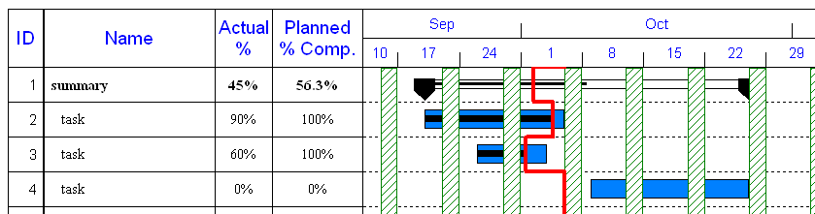
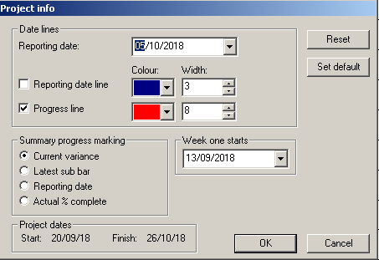The RED drop down line for Progress cuts the task bars at the end of the % complete marking (based on working days on that task). However for the Summary Bars - there are 4 methods to decide where to cut these...
(default) Current Variance
Latest Sub Task
Reporting Date
Actual % complete
To change the method select PROJECT menu | PROJECT INFO & then click one of the 4 options.
Note: The % complete at Summary level is ignored by the system and uses another way to mark up the Summary Bar.
The black line inside the Summary Bar is based on % of sub tasks below and is not an accurate way to position the Red Line especially when there are many concurrent tasks – that are especially behind plan.
Where many tasks are behind then Method 3 or4 should be the preferred method to use.

- Office applications open automatically when exporting

When exporting from Project Commander to MS Office, it will automatically open up the Office product.
If there is a problem opening MS Office – you will be prompted for a appropriate file to save the data.
There are 3 export options .
Excel - export various cost/cashflow data spreadsheets (as a .csv file)
Clipboard – save a .wmf file for the current page on view to paste into Word or PowerPoint
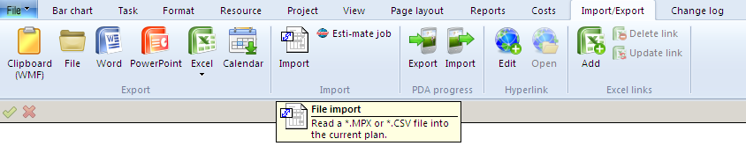
Word or PowerPoint – starts up an empty document ready to paste an image into.

- Change Total Cost and Cumulative Cost to Forecast Cost and Forecast
Cumulative Cost in Cost Reports
The Actual Cost column for tasks is calculated by TOTAL COST x ACTUAL %. All Cost reports will use the Actual and Total Cost.

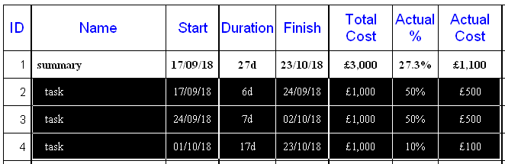

If you adjust the Actual Cost or edit the % Cost Complete, then all Cost reports will use the Actual and Forecast Cost.

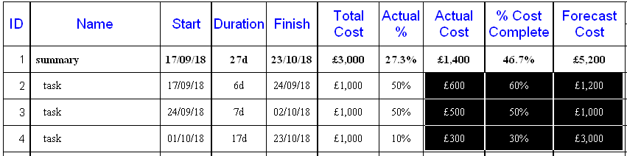

Forecast Cost is calculated by TOTAL COST x COST COMPLETE % / ACTUAL %.

- Print alerts when % complete behind schedule
Set Alert on % complete behind schedule to default NO in Preferences
The coloured box in the Actual % column (VIEW menu PERCENT COMPLETE) is switched off by default.
To switch it on (for display and printing) FILE menu | OPTIONS | PREFERENCES .... click on GENERAL tab & then tick ALERT ON %COMPLETE BEHIND SCHEDULE.
So now we have made it WYSIWYG - they will only print if on-screen.
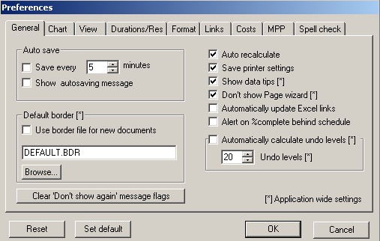

- Create CPA Analysis Report
When calculating CPA – there now is an extra option to Create a CPA Report – which fully analyses the project plan to assess potentially issues/errors in your CPA.
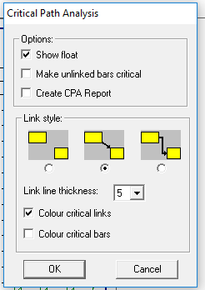
To both calculate CPA and initialise the CPA Analysis Report – click on option below and then OK.
You can choose what you want the Report to analyse. To choose full analysis click on SELECT ALL
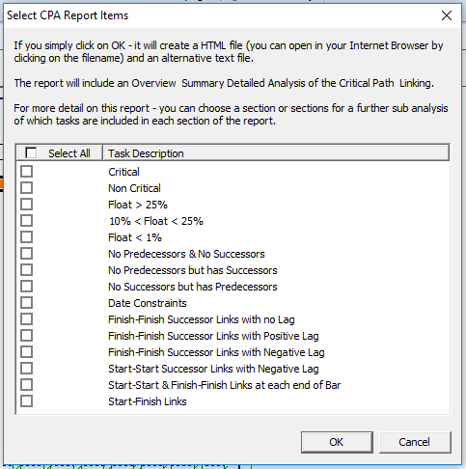
The Analysis Report is then created and you will be asked to save it in .html format – that can be opened using your Browser. It will also save a text version to the same file name – that can be opened in Notepad or Word.
The Report will be in three sections ..
An overview of CPA
An INITIAL ANALYSIS
A DETAILED ANAYSIS
The Analysis is broken down into sections of
Number of Critical items
Floats
Broken Links
Date constraints
Unusual Links
Accuracy score
FLOAT
For tasks that have a float greater than 25 percent of project duration, that amount of float would normally be considered too high and would need to be investigated. It could suggest that there is possibly an issue with linking especially missing finish links.
BROKEN LINKS
For Critical Path Analysis to calculate correctly all bars must be linked with one or more links going into a bar and one or more links out of a bar. Bars that have no links will break paths. Tasks with no Successor can show incorrectly a large float to the end of the project.
Where there are independent paths or subprojects it is acceptable that the first and last tasks will not be linked.
DATE CONSTRAINTS
Date Constraints (such as Must Start, Start no Earlier, etc) will effect the CPA greatly
UNUSUAL LINKS
Any unusual links like lots of FF or SF or SS-lag links are listed for potential further investigation.
ACCURACY
The accuracy of CPA is improved with an increased average number of links per task. On a complex project – the average number of links per task should be approximately 3-4. On a simpler project the average number of links per task should be 2-3. The higher the average – the more accurate the CPA and floats will be. Projects with an average of 1.25 or less are liable to produce a suspect CP.

